Lab Objective

Learn how to Configure a Password Settings Object

**Lab Procedures**

**1.** On RWDC01, with Group Policy Management, navigate to and click the EastOU.

**2.** Right-click the East OU and select Block Inheritance. An exclamation point inside a blue circle appears for the container as shown in Figure 19-2.

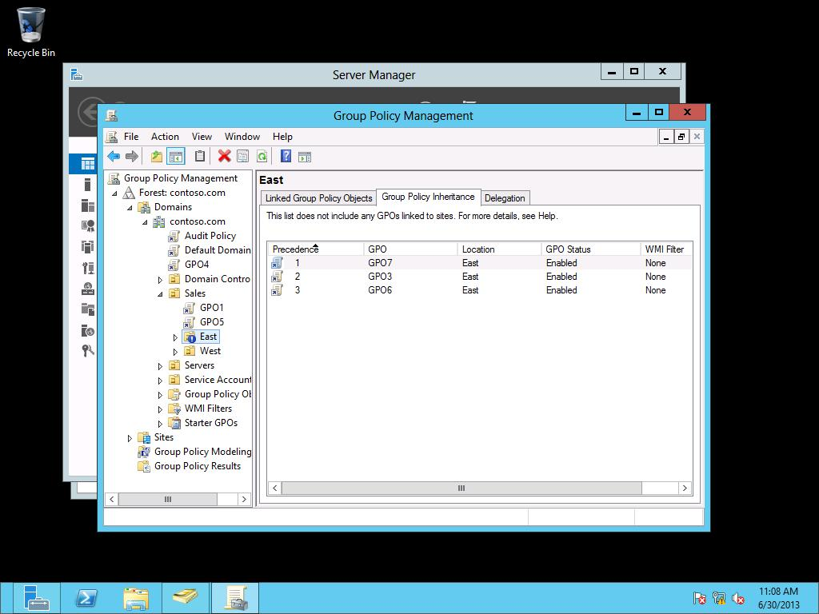

Figure 19-2

Viewing the East OU with block inheritance

**3.** Click the Group Policy Inheritance tab.

**4.** Right-click GPO4, and click Enforced.

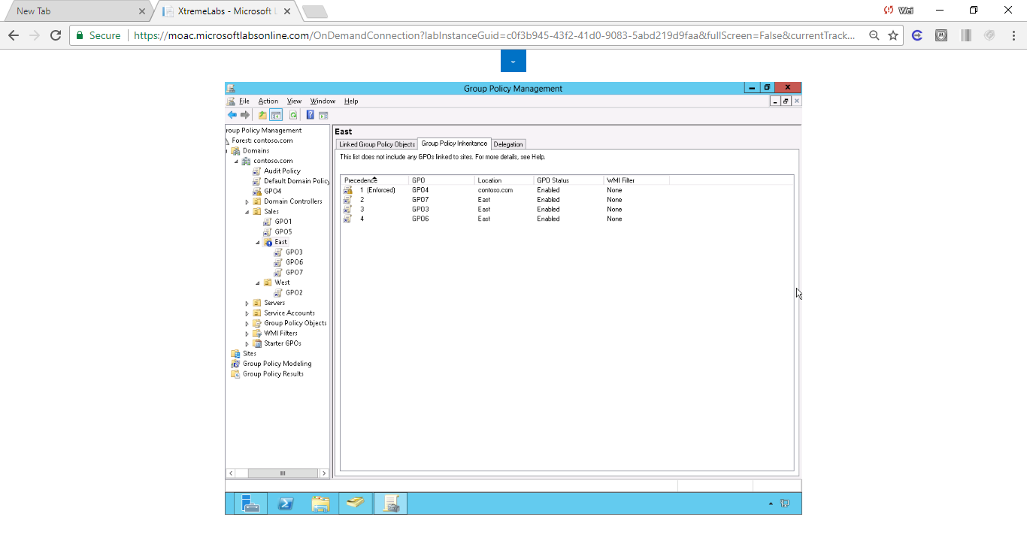

Figure 1 East OU shows the list GPOs with GPO4 Enforced on the top, GPO7 second on the top, and characters in descending order for the other GPOs.

**5.** Take a screen shot of the Group Policy Management window by pressing Alt+Prt Scr and then paste it into your Lab19_worksheet file in the page provided by pressing Ctrl+V.

**6.** Leave the Group Policy Management console open for the next exercise.

End of exercise. You can leave the windows open for the next exercise.

**Lab Summary**

During this exercise, I modified the order and precedence of GPOs by blocking inheritance and using enforced policies. The precedence of the GPOs assigned to the OU usually takes by the names in ascending order. The GPO assigned to the OU usually takes the precedence over those assigned to its parent. The enforced policies usually take precedence over any other policies and order can be modified through the double up arrow icons.